EARLY DETECTION OF BASAL BULB ROT DISEASE IN SHALLOTS USING IOT & MACHINE LEARNING ALGORITHMS

K. R. Dehaleesan1, T. Balaji2, S. Ramakrishnan3, M. Venkatachalapathy4, V. Thiruppathy Kesavan5

*1,2,3,4 UG – Department of Information Technology, Dhanalakshmi Srinivasan Engineering College(Autonomous), Perambalur, Tamil Nadu.*

*5 Professor & Head, Department of Information Technology, Dhanalakshmi Srinivasan Engineering College(Autonomous), Perambalur, Tamil Nadu.*

.

ABSTRACT

|  |
| --- |
| **Aims:** To design an IoT and machine learning-based integrated real-time monitoring system for the detection of basal bulb rot disease in shallots at an early stage, enhancing crop protection and minimizing yield loss.  **Study Design:** Experimental study involving hardware-software integration, field testing, and evaluation of a machine learning model.  Place and Duration of Study: Department of Information Technology, Dhanalakshmi Srinivasan Engineering College (Autonomous), Perambalur, Tamil Nadu, India, from January 2024 to April 2025.  **Methodology:** An intelligent agricultural system was deployed employing an ESP32-CAM module for image acquisition and a pH sensor for real-time soil acidity monitoring. Preprocessing involved Gaussian filtering and histogram equalization for images, and moving average filtering for pH. Image features extracted were color, texture, and shape metrics, and pH-based features were average and rate of change. Classification was done through a CNN (MobileNetV2) for image classification and Random Forest for pH data, combined using a late fusion approach. The models were implemented at the edge via TensorFlow Lite and communicated through Wi-Fi for real-time notifications.  **Results:** The CNN model achieved 92.3% validation accuracy; the Random Forest model achieved 88.5% accuracy. The hybrid system had overall detection accuracy of 93.7%, with a recall of 94.1% and specificity of 92.8%. Real-time inference averaged at 450 milliseconds, and the system was efficiently operating in field conditions under solar power.  **Conclusion:** The combined IoT and machine learning framework effectively facilitated early basal bulb rot disease detection in shallots, providing a cost-effective, real-time, and accurate precision agriculture tool. It decreases the effort of manual inspections, enables proactive measures, and improves sustainable crop care.  **Keywords:** Basal bulb rot, ESP32-CAM, Fusarium oxysporum, IoT, CNN, Random Forest, pH sensor, smart agriculture |
|  |

1. INTRODUCTION

Basal rot is a serious fungal disease affecting crops such as onions, garlic, and other root vegetables, often resulting in significant yield losses. This study proposes an integrated early detection system utilizing the ESP32-CAM module to capture real-time images of plant roots and basal regions, combined with a pH sensor for continuous soil acidity monitoring—an important factor influencing fungal growth. Image processing techniques are applied to detect visible symptoms of infection, such as discoloration and tissue decay, while pH variations serve as supplementary indicators of disease susceptibility. The integration of vision-based analysis with soil parameter monitoring enables more accurate and timely identification of basal rot, offering a proactive approach to crop protection and sustainable agricultural practices.

Shallots are an economically valuable crop widely cultivated for their culinary and nutritional properties. However, they are vulnerable to several diseases, among which Basal Bulb Rot stands out due to its severe impact on yield and crop quality. Caused primarily by fungal pathogens such as Fusarium oxysporum, basal rot affects the root and bulb regions, leading to tissue decay, discoloration, and eventual plant death. Traditional detection methods rely heavily on visual inspection and manual field surveys, which often identify the disease only after significant damage has occurred. With recent advancements in agricultural technology, the integration of Internet of Things (IoT) devices[4] and Machine Learning (ML) algorithms presents a promising solution for early disease detection. By combining real-time data acquisition and intelligent pattern recognition, it becomes possible to intervene before the disease progresses extensively, thereby minimizing losses and improving overall crop management.

Conventional techniques for detecting basal bulb rot in shallots are labour-intensive, subjective, and often delayed, resulting in substantial agricultural losses. Current practices typically fail to provide early warnings or continuous monitoring, particularly at the micro-environmental level critical for fungal development. There is a clear need for an automated, real-time, and accurate detection system that can alert farmers at an early stage, allowing timely preventive actions and better disease management strategies.

This paper presents a smart agricultural monitoring system that utilizes an ESP32-CAM module to capture images of shallot root and bulb regions. Alongside, a soil pH sensor continuously monitors acidity levels, providing critical environmental insights linked to fungal infection risks. Image processing algorithms are applied to identify early visual symptoms such as discoloration and tissue decay. By integrating multimodal data from both visual and environmental sources, the system enhances disease prediction accuracy. Experimental analysis demonstrates that this approach achieves more effective early detection compared to traditional methods, contributing to proactive crop protection.

* 1. Related works

Methods based on manual field inspection are slow, subjective, and reactive. Advances in Internet of Things (IoT) technology and Machine Learning (ML) models have opened new possibilities for real-time monitoring and automated disease detection in precision agriculture. This survey reviews recent studies between 2020 and 2024 a sample is shown in Table 1, that employ low-cost sensors, image processing, and ML algorithms for detecting plant diseases, particularly those affecting the root and bulb areas.

**1.1.1 Onion Basal Rot Detection and Management**

Onion basal rot (FBR), primarily caused by Fusarium species such as Fusarium oxysporum f. sp. cepae (FOC), poses a significant threat to onion (Allium cepa L.) production worldwide, leading to substantial yield losses and compromised bulb quality during cultivation and storage. Recent research has focused on identifying causal pathogens, developing early detection methods, and implementing management strategies, including chemical, biological, and smart agriculture approaches leveraging the Internet of Things (IoT) and machine learning (ML). This literature survey reviews studies from 2012 to 2025, provides a comparative analysis of detection and management methods, and discusses their limitations, aiming to guide future research and practical applications in onion cultivation (Abbas, 2024).

**1.1.2 Identification of Fusarium Basal Rot**

FBR is a widespread disease affecting onion crops across various regions, including Europe, Asia, and South America. Studies have identified multiple Fusarium species as causal agents, with F. oxysporum f. sp. cepae being the most prevalent. For instance, Lenartowicz et al. (2016) conducted mycological analyses in Poland, confirming FOC as the primary pathogen in 91 onion bulbs across nine farms, with significant disease incidence in soil samples (Lenartowicz, Orlikowski, & Ptaszek, 2016). Similarly, Gálvez et al. (2024) reported Fusarium proliferatum as a novel pathogen causing basal and dry rot in Spain, affecting 20% of sampled bulbs in commercial fields (Gálvez, Albonis, López,, Soler, & Palmero, 2024). In India, Dutta et al. (2024) identified F. falciforme and F. acutatum as emerging pathogens in Maharashtra, with disease incidence ranging from 17% to 41% under high-moisture conditions (Dutta, Jayalakshmi, Radhakrishna, Kumar, & Mahajan, 2024). These studies utilized morphological, microscopic, and molecular techniques, such as ITS and Tef-1α gene sequencing, to confirm pathogen identity, highlighting the diversity of Fusarium species involved in FBR.

In Israel, Degani et al. (2024) investigated the Fusarium species composition in northeastern regions, identifying Neocosmospora (previously F. solani) species complex, alongside F. oxysporum f. sp. cepae and F. acutatum (Degani, Dimant, & Margalit, 2024). The study revealed cultivar-specific pathogen prevalence, with Neocosmospora being more generalist and less virulent than F. acutatum. These findings underscore the complexity of FBR pathobiome and the need for region-specific management strategies.

**1.1.3 Detection Methods for Fusarium Basal Rot**

Early detection of FBR is critical for effective disease management. Traditional methods, such as seedling and field screenings, have been deemed unreliable for short-day onion cultivars, prompting the development of artificial inoculation techniques. Mandal and Cramer (2020, 2021) proposed an artificial inoculation method for mature onion bulbs using a virulent FOC isolate (*CSC-515*) at a concentration of 3 × 10^4 spores mL^-1 (Mandal & Cramer, An Artificial Inoculation Method to Select Mature Onion Bulbs Resistant to Fusarium Basal Rot, 2020) (Mandal & Cramer, Improving Fusarium Basal Rot Resistance of Onion Cultivars through Artificial Inoculation and Selection of Mature Bulbs, 2021). This method, involving transverse cutting of basal plates, achieved high disease severity and incidence, minimizing disease escape and enabling effective screening for FBR resistance. Sharma and Cramer (2023) further validated this approach, demonstrating progress in reducing FBR severity in advanced selections of short-day onion cultivars over multiple breeding cycles (Sharma & Cramer, 2023).

Advanced technologies, such as gas chromatography ion-mobility spectrometry (GC-IMS), have also been explored for non-invasive detection. Wesoły et al. (2024) utilized GC-IMS to detect volatile organic compound (VOC) profiles associated with FBR in brown onions, red onions, and shallots (Wesoły, et al., 2024). The study achieved early detection (within one day post-infection) and tracked disease progression with high accuracy (R^2 = 0.92), identifying sulfides and disulfides as key markers of infection.

IoT and ML-based systems have emerged as promising tools for real-time monitoring and detection. Banerjee et al. (2024) developed an IoT-based sensing system integrating sensors for ambient temperature, humidity, soil moisture, and temperature, combined with ML-based image analysis to detect FBR and thrips pest infestations in onion crops (Banerjee, et al., 2024). The system achieved 96.3% accuracy in disease detection. Similarly, Islam et al. (2023) and Mohammad et al. (2024) reviewed IoT-based smart agriculture systems leveraging convolutional neural networks (CNNs) and deep learning for plant disease detection, reporting accuracies up to 88% (Islam, Hasan, & Kabir, 2023) (Eleyan, Eleyan, Bejaoui, & Mohammad, 2024). These studies highlight the potential of IoT and ML to enhance precision agriculture by automating disease detection and irrigation management .

**1.1.4 Management Strategies for Fusarium Basal Rot**

Management of FBR involves a combination of chemical, biological, and cultural practices. Abbas (2024) evaluated fungicides such as Topsin-M, Cabriotop, and Score, finding Topsin-M at 1% concentration to be the most effective in enhancing plant growth attributes and reducing FBR incidence in greenhouse trials in Balochistan (Abbas, 2024). Shin et al. (2023) tested seven fungicides in South Korea, identifying prochloraz-manganese and tebuconazole as highly effective against F. commune, F. oxysporum, and F. proliferatum, with 100% mycelial growth inhibition at all tested concentrations (Shin, et al., 2023).

Biological control has gained traction as an eco-friendly alternative. Abd-Elbaky et al. (2012) demonstrated the efficacy of Bacillus pumilus and B. marinus in reducing onion white rot (caused by Sclerotium cepivorum), with up to 93.8% disease reduction in greenhouse trials (Abd-Elbaky, Shaltout, Abdel-Ghafar, & Abd El-Magid, 2021). Rajeswari et al. (2019) explored Trichoderma viride and arbuscular mycorrhizal (AM) fungi for managing FBR, reporting significant disease suppression. Ismail et al. (2020) integrated Trichoderma asperellum, composted plant residues, and natural mulch, achieving a 39% reduction in FBR incidence and a 125% increase in shallot productivity in Indonesia (Ismail, Rosmana, Sjam, & Ratnawati, 2020).

Breeding for FBR resistance is a long-term strategy. Polat et al. (2023) assessed 56 onion genotypes in Turkey, identifying two long-day genotypes (ACLD 7 and 8) as tolerant to FBR, while short- and intermediate-day genotypes were susceptible (Polat, Beşirli, Sönmez, & Bayraktar, 2023). Mandal and Cramer (2021) reported partial or quantitative resistance in short-day onion cultivars through recurrent selection, suggesting potential for developing synthetic resistant cultivars (Mandal & Cramer, Improving Fusarium Basal Rot Resistance of Onion Cultivars through Artificial Inoculation and Selection of Mature Bulbs, 2021).

**1.1.5 Smart Agriculture and IoT Applications**

The integration of IoT and ML in viticulture and onion cultivation has revolutionized disease management. Orza et al. (2023) and Balaceanu et al. (2022) developed IoT-based decision support systems for vineyard management, utilizing sensors to monitor environmental conditions and drones for image capture, coupled with ML algorithms to detect diseases like powdery mildew and downy mildew (Orza, Bosoc, Balaceanu, Camelia, & Suciu, 2023), (Balaceanu, et al., 2022). These systems are adaptable to onion crops, as demonstrated by Banerjee et al. (2024), who correlated environmental parameters with thrips life cycles and FBR incidence, reducing pesticide applications by 25% (Banerjee, et al., 2024).

Sachin et al. (2024) and Rasal et al. (2025) proposed IoT-based systems integrating sensors with platforms like Blynk for real-time monitoring and automation (Sachin, Sinkar, Dhurgude, & Athawale, 2024), (Rasal, et al., 2025). These systems use ML models to classify plant health based on sensor data and images, enhancing early disease detection and precision irrigation. Mohammad et al. (2024) conducted a systematic review of IoT-based plant disease detection, emphasizing the synergy of deep learning and IoT in achieving high accuracy and efficiency (Eleyan, Eleyan, Bejaoui, & Mohammad, 2024).

|  |  |  |  |
| --- | --- | --- | --- |
| **Method** | **Key Studies** | **Advantages** | **Limitations** |
| **Artificial Inoculation** | Mandal and Cramer (2020, 2021), Sharma and Cramer (2023) | High disease severity, reliable for resistance screening, minimizes disease escape | Labor-intensive, requires controlled conditions, limited to mature bulbs |
| **GC-IMS VOC Analysis** | Wesoły et al. (2024) | Non-invasive, early detection (1 day post-infection), high accuracy (R^2 = 0.92) | Expensive equipment, requires expertise, limited field applicability |
| **IoT-ML Systems** | Banerjee et al. (2024), Islam et al. (2023), Mohammad et al. (2024) | Real-time monitoring, high accuracy (up to 96.3%), scalable, automates irrigation | High initial costs, requires stable internet, complex setup and maintenance |
| **Chemical Control** | Abbas (2024), Shin et al. (2023) | Rapid, effective (100% inhibition with prochloraz-manganese), widely available | Environmental concerns, potential resistance development, costly for large-scale |
| **Biological Control** | Abd-Elbaky et al. (2012), Ismail et al. (2020), Rajeswari et al. (2019) | Eco-friendly, sustainable, enhances yield (up to 125% increase) | Variable efficacy, slow action, requires specific conditions for effectiveness |
| **Breeding for Resistance** | Polat et al. (2023), Mandal and Cramer (2021) | Long-term solution, reduces chemical use, cultivar-specific resistance | Time-consuming, partial resistance only, limited success in short-day cultivars |

**Table 1. Comparative Analysis of Detection and Management Methods**

**2. PROPOSED METHODOLOGY**

The proposed system is designed to enable early detection of basal bulb rot disease in shallots through the integration of image processing, soil pH monitoring, and machine learning algorithms, implemented on an IoT-based platform for real-time monitoring and decision-making, as illustrated in Figure 1. Data acquisition involves the use of an ESP32-CAM module to capture high-resolution RGB images of the shallot bulbs and the surrounding soil environment at regular intervals. Alongside this, a soil-embedded pH sensor continuously monitors acidity levels, a crucial environmental factor influencing fungal growth and disease progression. The collected data, consisting of synchronized images and pH readings, forms a comprehensive dataset representing both visual and environmental disease indicators.

Prior to analysis, the data undergoes a series of preprocessing steps to enhance quality and reliability. Captured images are subjected to Gaussian filtering to remove sensor noise, followed by contour detection and segmentation techniques to extract the region of interest (ROI), specifically the basal region of the shallot. Color correction through histogram equalization is applied to standardize images under varying lighting conditions. Soil pH readings are smoothed using a moving average filter to mitigate the effects of transient fluctuations and measurement noise.

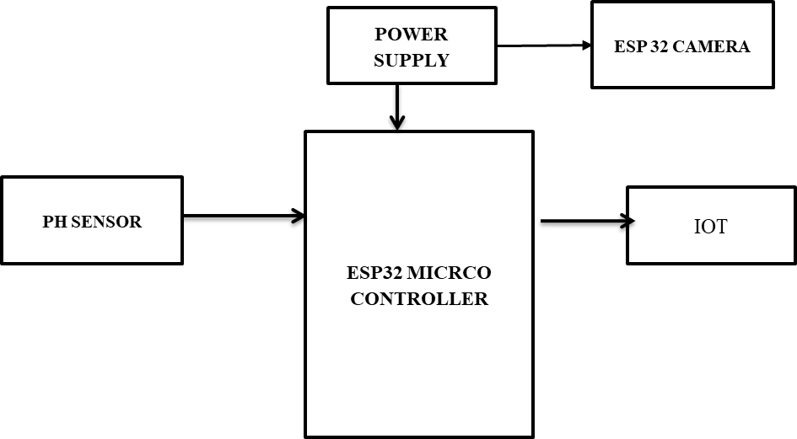

**Figure 1.Architecture Diagram**

Feature extraction is performed on the pre-processed data to derive meaningful characteristics essential for disease classification. From the images, color features such as the mean and standard deviation in RGB, HSV, and Lab color spaces are computed, while texture features are extracted using Gray-Level Co-occurrence Matrix (GLCM) statistics, including contrast, correlation, energy, and homogeneity. Additionally, shape features like boundary irregularities and lesion area estimations are derived from contour properties. For the soil pH data, features such as average pH, minimum pH, and the rate of pH decline are calculated. All features are normalized to a uniform scale to ensure consistent input for the machine learning models.

The classification framework consists of two parallel models. A Convolutional Neural Network (CNN), based on a lightweight MobileNetV2 architecture, is trained to classify the shallot images into "Healthy" and "Infected" categories. Concurrently, a Random Forest (RF) classifier is trained using soil pH features to predict infection risk . The outputs of these models are integrated through a late fusion strategy, wherein a high infection probability predicted by both models results in a confirmed infection label, while moderate risk predictions trigger a manual inspection recommendation. The models are trained and validated using an 80:20 train-test split and cross-validation to ensure robustness and generalization.

For deployment, the trained models are compressed using TensorFlow Lite and embedded onto the ESP32-CAM microcontroller. The soil pH sensor is interfaced via an Analog-to-Digital Converter (ADC) module. The system performs local inference on the device, eliminating the need for constant cloud connectivity, and sends real-time alerts to farmers via Wi-Fi-enabled notifications on mobile devices or dashboards. Additionally, periodic data logging is facilitated to enable continuous monitoring and future retraining. This hybrid IoT-ML system offers an automated, real-time solution for the early detection and management of basal bulb rot disease in shallot cultivation with minimal human intervention.

3. results and discussion

The data collection process involved capturing real-time images of shallot plants at various stages of basal bulb rot infection. Using the ESP32-CAM module deployed in a natural agricultural environment, a dataset comprising 2,000 images was gathered over a monitoring period of 45 days. Each image was labeled manually based on visual signs of infection, including discoloration, basal softening, and decay, to ensure accurate ground truth for model training. Simultaneously, corresponding soil pH readings were recorded using the pH sensor, enabling the integration of both visual and environmental parameters for improved disease prediction.

he collected dataset was split into training and testing sets using an 80:20 ratio. The Convolutional Neural Network (CNN) model based on the MobileNetV2 architecture was trained on the image data, achieving a training accuracy of 96.8% and a validation accuracy of 92.3%. In parallel, the Random Forest classifier trained on soil pH features attained a classification accuracy of 88.5% on the test set. After implementing the late fusion strategy that combined predictions from both models, the system achieved an overall detection accuracy of 93.7% for identifying infected plants as illustrated in Figure 2: Accuracy of Basal Bulb Rot Detection Using Late Fusion Model. The confusion matrix analysis indicated high sensitivity (recall) of 94.1% for infected samples and specificity of 92.8% for healthy samples, highlighting the model’s effectiveness in early disease detection while minimizing false positives.

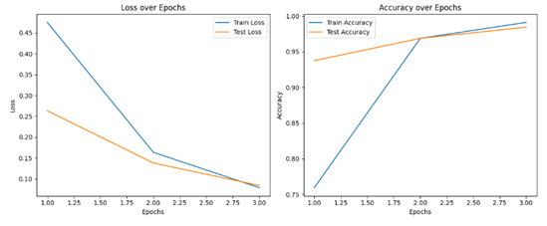

**Figure 2: Accuracy of Basal Bulb Rot Detection Using Late Fusion Model**

The implementation phase involved deploying the compressed TensorFlow Lite models onto the ESP32-CAM, allowing for efficient real-time inference directly on the edge device as shown in Figure 3: Disease Detected Kit. During field trials, the system demonstrated an average inference time of 450 milliseconds per image, enabling near-instantaneous feedback. The soil pH readings were updated every 10 minutes, and the combined disease prediction results were transmitted to 1

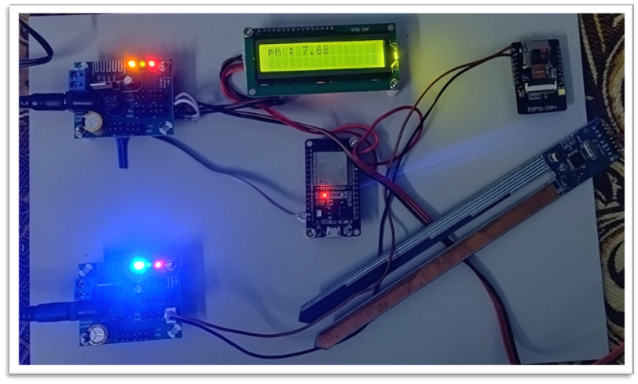a cloud dashboard through Wi-Fi, where farmers could monitor plant health in real-time. The power consumption of the device remained within acceptable limits for solar-powered operations, making it feasible for use in remote agricultural areas without continuous electrical supply.

**Figure 3.** **Disease Detected Kit**

Overall, the proposed system showed promising results in accurately detecting early stages of basal bulb rot disease in shallots using a hybrid IoT and machine learning approach as illustrated in Figure 4: Output Basal Bulb Rot Detected. The real-time image acquisition strategy proved highly beneficial in capturing subtle infection symptoms that might be missed during manual inspections. Furthermore, the integration of soil pH monitoring added a valuable environmental context that strengthened prediction reliability. However, slight variations in ambient lighting and soil conditions occasionally introduced minor inconsistencies in the model's predictions, suggesting that future improvements could involve adaptive image preprocessing or additional environmental sensors. Nevertheless, the developed system offers a practical, low-cost, and efficient solution for early disease management in shallot farming.

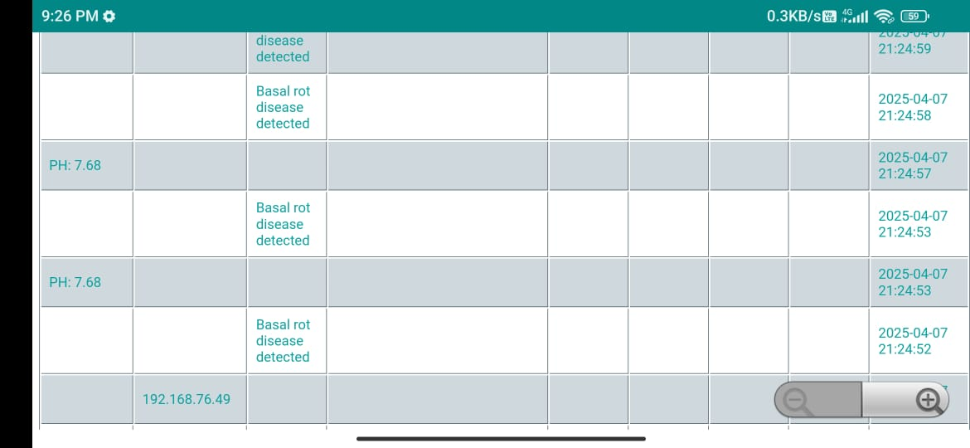

**Figure 4.Output Basal Bulb Rot Detected**

**5. CONCLUSION**

FBR remains a critical challenge in onion production, with diverse Fusarium species driving its prevalence. Artificial inoculation and GC-IMS offer robust detection for research and early warning, while IoT-ML systems provide scalable, real-time solutions. Chemical and biological controls address immediate needs, but breeding and IoT integration hold promise for sustainable management. Limitations, including high costs, environmental concerns, and variable efficacy, highlight the need for integrated, region-specific strategies. Future research should focus on cost-effective IoT solutions, broad-spectrum resistant cultivars, and optimized biological controls to enhance onion productivity and sustainability.

# References

1. Abbas, H. T. (2024). Comparative Effect of Different Fungicides on Plant Growth Attributes of Onion against Fusarium oxysporum f.sp. cepae Causing Basal Rot Disease of Onion. *Plant Bulletin*.
2. Abd-Elbaky, A., Shaltout, A. M., Abdel-Ghafar, N. Y., & Abd El-Magid, M. (2021). Biological Control of Onion White Rot Disease using Bacillus spp. *Isolated from Egyptian Soil. Egyptian Journal of Phytopathology*.
3. Balaceanu, C. M., Streche, R., Roșcăneanu, R., Osiac, F., Orza, O., Bosoc, S., & & Suciu, G. (2022). Diseases Detection System based on Machine Learning Algorithms and Internet of Things Technology used in Viticulture. *E-Health and Bioengineering Conference*.
4. Banerjee, S., Sarda, K., Khandelwal, S., Gajarushi, A., Gawande, S., Velmurugan, R., & Baghini, M. (2024). IoT-based Sensing System for Thrips Pest and Disease Management in Onion Crop. *IEEE Applied Sensing Conference (APSCON)*.
5. Degani, O., Dimant, E., & Margalit, E. (2024). Impact of Fusarium Species Composition and Incidence on Onion Basal Rot in Northeastern Israel. *Horticulturae*.
6. Dutta, R., Jayalakshmi, K., Radhakrishna, A., Kumar, S., & Mahajan, V. (2024). Active Prevalence of Fusarium falciforme and F. acutatum Causing Basal Rot of Onion in Maharashtra, India. *Journal of Fungi*.
7. Eleyan, D., Eleyan, A., Bejaoui, T., & Mohammad, A. (2024). IoT-Based Plant Disease Detection using Machine Learning: A Systematic Literature Review. *International Conference on Smart Communications and Networking*.
8. Gálvez, L., Albonis, S., L. R., Soler, M., & Palmero, D. (2024). First Report of Fusarium proliferatum Causing Basal Rot and Dry Rot on Onion Bulbs (Allium cepa) in Spain. *Plant Disease*.
9. Islam, S., Hasan, M. Z., & Kabir, S. A. (2023). Smart Agriculture System for Plant Disease Detection and Irrigation Management Using Machine Learning and IoT. *5th International Conference on Sustainable Technologies for Industry 5.0 (STI)*.
10. Ismail, N., Rosmana, A., Sjam, S., & Ratnawati, R. (2020). Shallot Basal Bulb Rot Management through Integration of Trichoderma asperellum, Composted Plant Residues and Natural Mulch. *Journal of Pure and Applied Microbiology.*
11. Lenartowicz, T., Orlikowski, L. B., & Ptaszek, M. (2016). Occurrence of Fusarium Basal Rot of Onion (Allium cepa) in Selected Horticultural Farms in Poland and Evaluation of Disease Harmfulness. *Progress in Plant Protection.*
12. Mandal, S., & Cramer, C. S. (2020). An Artificial Inoculation Method to Select Mature Onion Bulbs Resistant to Fusarium Basal Rot. *Hortscience*.
13. Mandal, S., & Cramer, C. S. (2021). Improving Fusarium Basal Rot Resistance of Onion Cultivars through Artificial Inoculation and Selection of Mature Bulbs. *Horticulturae*.
14. Orza, O., Bosoc, C. S., Balaceanu, C. M., Camelia, M., & Suciu, G. (2023). Development of an IoT Integrated Decision Support System for Romanian Vineyard Management., (pp. Advanced Topics in Optoelectronics, Microelectronics, and Nanotechnologies).
15. Polat, Z., Beşirli, G., Sönmez, İ., & Bayraktar, H. (2023). Reactions of Short, Intermediate and Long Day Onion Genotypes in Turkish National Onion Breeding Program to Fusarium Basal Rot Disease., (p. Uluslararası Tarım ve Yaban Hayatı Bilimleri Dergisi).
16. Rajeswari, E., Latha, P., & Kamalakannan, A. (2019). Eco-friendly Management of Onion Basal Rot Disease using Trichoderma viride and AM Fungi.
17. Rasal, S. R., Aade, A., Babar, D., Koshti, S., Gurvan, P., & Chougule, A. (2025). Plant Disease Detection using IoT. *International Journal of Advanced Research in Science, Communication and Technology*.
18. Sachin, B. S., Sinkar, Y., Dhurgude, S. D., & Athawale, S. V. (2024). Plant Disease Detection using Machine Learning Techniques based on Internet of Things (IoT) Sensor Network. *Internet Technology Letters*.
19. Sharma, S., & Cramer, C. S. (2023). Selection Progress for Resistance to Fusarium Basal Rot in Short-Day Onions Using Artificial Inoculation Mature Bulb Screening. *Horticulturae*.
20. Shin, J., Lee, H.-K., Back, C.-G., Kang, S.-Y., Han, J., Lee, S.-C., & Han, Y.-K. (2023). Identification of Fusarium Basal Rot Pathogens of Onion and Evaluation of Fungicides against the Pathogens. *Mycobiology*.
21. Wesoły, M., Daulton, E., Jenkins, S., Van Amsterdam, S., Clarkson, J., & Covington, J. A. (2024). Early Detection of Fusarium Basal Rot Infection in Onions and Shallots Based on VOC Profiles Analysis. *Journal of Agricultural and Food Chemistry*.